Casey Bladow
Assignment 01
1/15/15

1. Give a description of your previous experience with Linux. Where would you put yourself on the 0-10 Linux scale described in the syllabus?
I can't say I have a whole lot of experience using Linux, however, I have played with a tad here and there when necessary in a situation that calls for it. It has been a long time since I learned all the ins and outs of the OS. 3-4.
3. Answer each of the exercise questions at the end of chapter 1.
ANSWER ME
5. What is a virtual machine? List some advantages of virtual machines.
A virtual machine is like a pretend computer running inside your computer. Pretty awesome really. Enabling you have multiple Operating Systems installed and never having to mess with you actual hard drive. (No partitioning!) I have found they are great to install just for a class or two. You can use them, abuse them, fill them full of stuff you'll never use again after 16 weeks, back up the necessary files you would like to keep, and scrap the rest. The list of advantages goes on and on. Like I just mentioned. You could also use them when you need them, hackers are known for this when it comes to doing some penetration testing. In reality, you could have a whole secret life hidden inside another virtual machine. And until someone figures out how to boot it, log into it, and gain access... they'll never know.
7. What virtual machine did you choose and why?
I went with Vmware because I've used VirtualBox prior and use Fusion at home.
10. List some of the best Linux distros described in the articles.
ANSWER ME
11. Why are there so many Linux distros?
Linux is free and open source. This enables everyone and their grandmother to download a copy, tweak it to their liking, and send it out for the world to share.
13. Include a screenshot of your virtual machine software that shows your Ubuntu virtual machine.
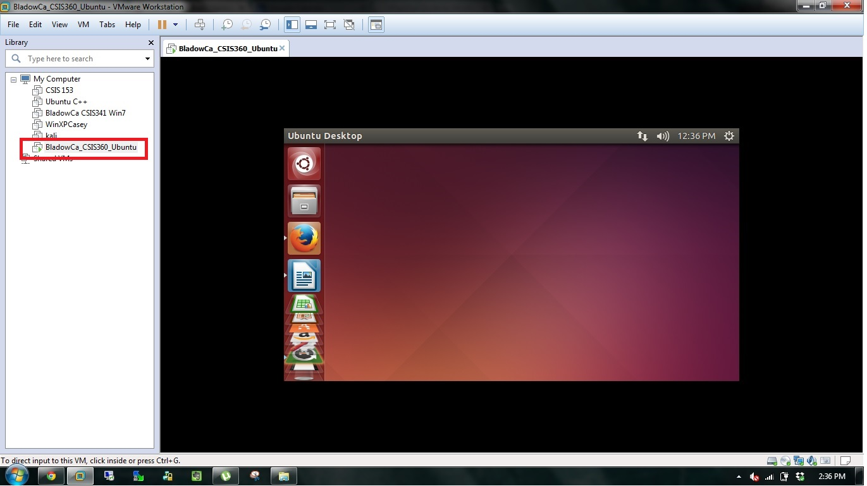
14. Include a screenshot of your Ubuntu desktop.
15. What did you learn from this assignment?
ANSWER ME

